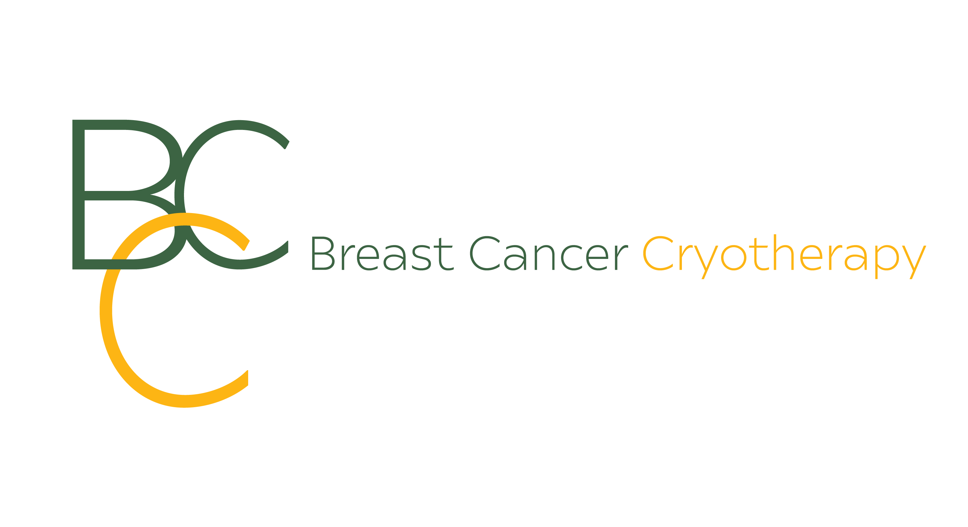

Post Breast Cryotherapy Procedure Note

Patient Name: ______________________________________

Please review the following information for an uneventful recovery. Please ask any questions regarding this before or after your procedure.

Wound Closure:

Steri-strip: 2-3 small sterile tape dressings will be applied over the incision site. These strips should fall off on their own within 3-5 days. If not, you may remove them after 1 week. However, if redness or irritation begins, please remove and place a bandage over the incision.

Your Dressing:

Gauze: Maintain the gauze pressure bandage taped over the incision site for 24 hours; you then may remove the gauze bandage. The steri-strips stay on for 3-5 days.

Elastic Wrap: We have applied an elastic wrap around your breasts for stability and comfort. You should keep the wrap in place for 24 hours, then wear a sports bra for the next 3-5 days. After the elastic wrap is removed you can take the pressure dressing off your cryo site. Please do not remove the steri-strips for 3-5 days.

Discomfort Management:

Discomfort is usually mild, and if needed, Over the Counter medications such as acetaminophen (Tylenol- Extra-Strength 2 tabs/every 4-7 hours as needed.)

General Information:

You may notice some pink-tinged or light bloody drainage on the bandage. This is normal. Notify Dr. Barclay-White if the drainage appears to be excessive.

You may notice swelling as well as a hard palpable lump that is larger than that treated tumor. This is caused by inflammation from the freezing process. This is normal and may take several months to soften. Resolution rates vary by individual and depend on the original tumor size as well as other physiological factors. This area will be palpable for 3-18 months after the procedure. Overtime, the palpable area will reduce in size, and your body will replace ablated tissue with healthy tissue.

Wear a bra after the procedure. You will probably be most comfortable in a snug fitting bra such as a sports bra as it will provide support for the treatment area. For the first few days, you may also be more comfortable sleeping in your bra. Refrain from strenuous exercise for about a week. You may return to regular daily activity at any time.

Some bruising at the probe insertion site and treatment site may develop within a few days. This is normal and will begin to resolve within about a week. You may have redness from the saline used to protect the skin from frostbite. This is normal and will start to resolve within a week.

If the area becomes red and hot, or you develop a fever, please contact doctor right away. This a can be a sign of infection.

Your first breast exam following cryoablation will serve as a new baseline for treatment. It is extremely important to inform your healthcare team that you have undergone cryoablation treatment to avoid any issues with future mammograms or breast imaging.

*All future imaging will be paid by you; or your health insurance. The cost today is only for the cryotherapy procedure.
*You will be followed for 5 years post cryotherapy. Please have follow-up imaging reports sent to dr.bw@breastcancercryo.com and tracey@breastcancercryo.com

Please call Dr. Barclay-White at (602) 826-9439 if you experience excessive bleeding, excessive swelling, severe discomfort, fever or drainage from the incision.

Patient Signature ______________________________________________________________________________ Date __________

Technologist Signature _________________________________________________________________________ Date ___________

Physician Signature ____________________________________________________________________________ Date ___________

